AWS Task-1

Task Description:

Create a windows Vm machine in AWS and connect with RDP open CMD in windows share the about system info.

Output: -

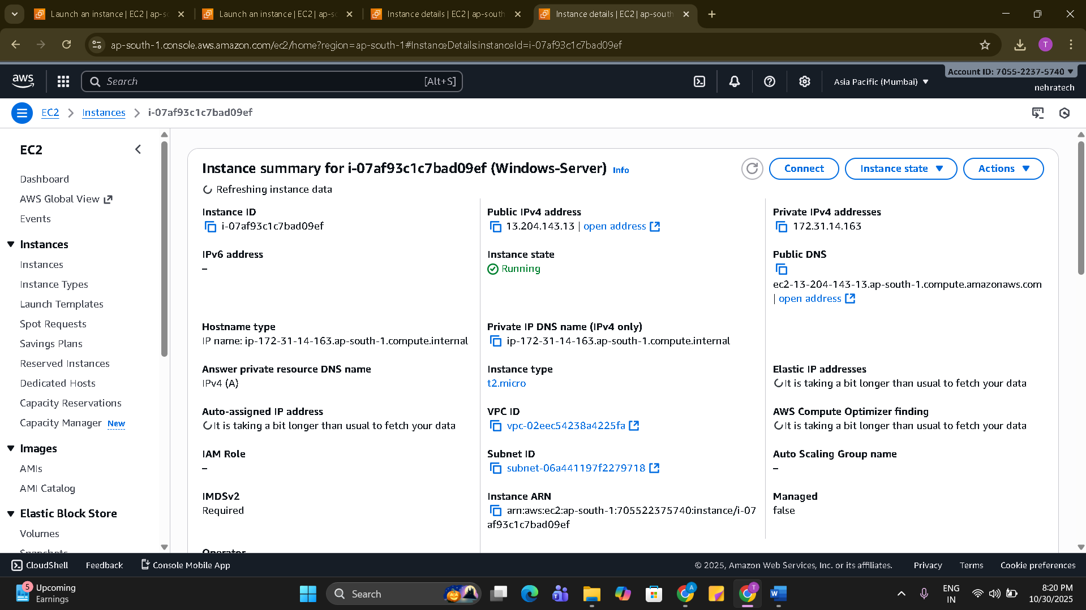

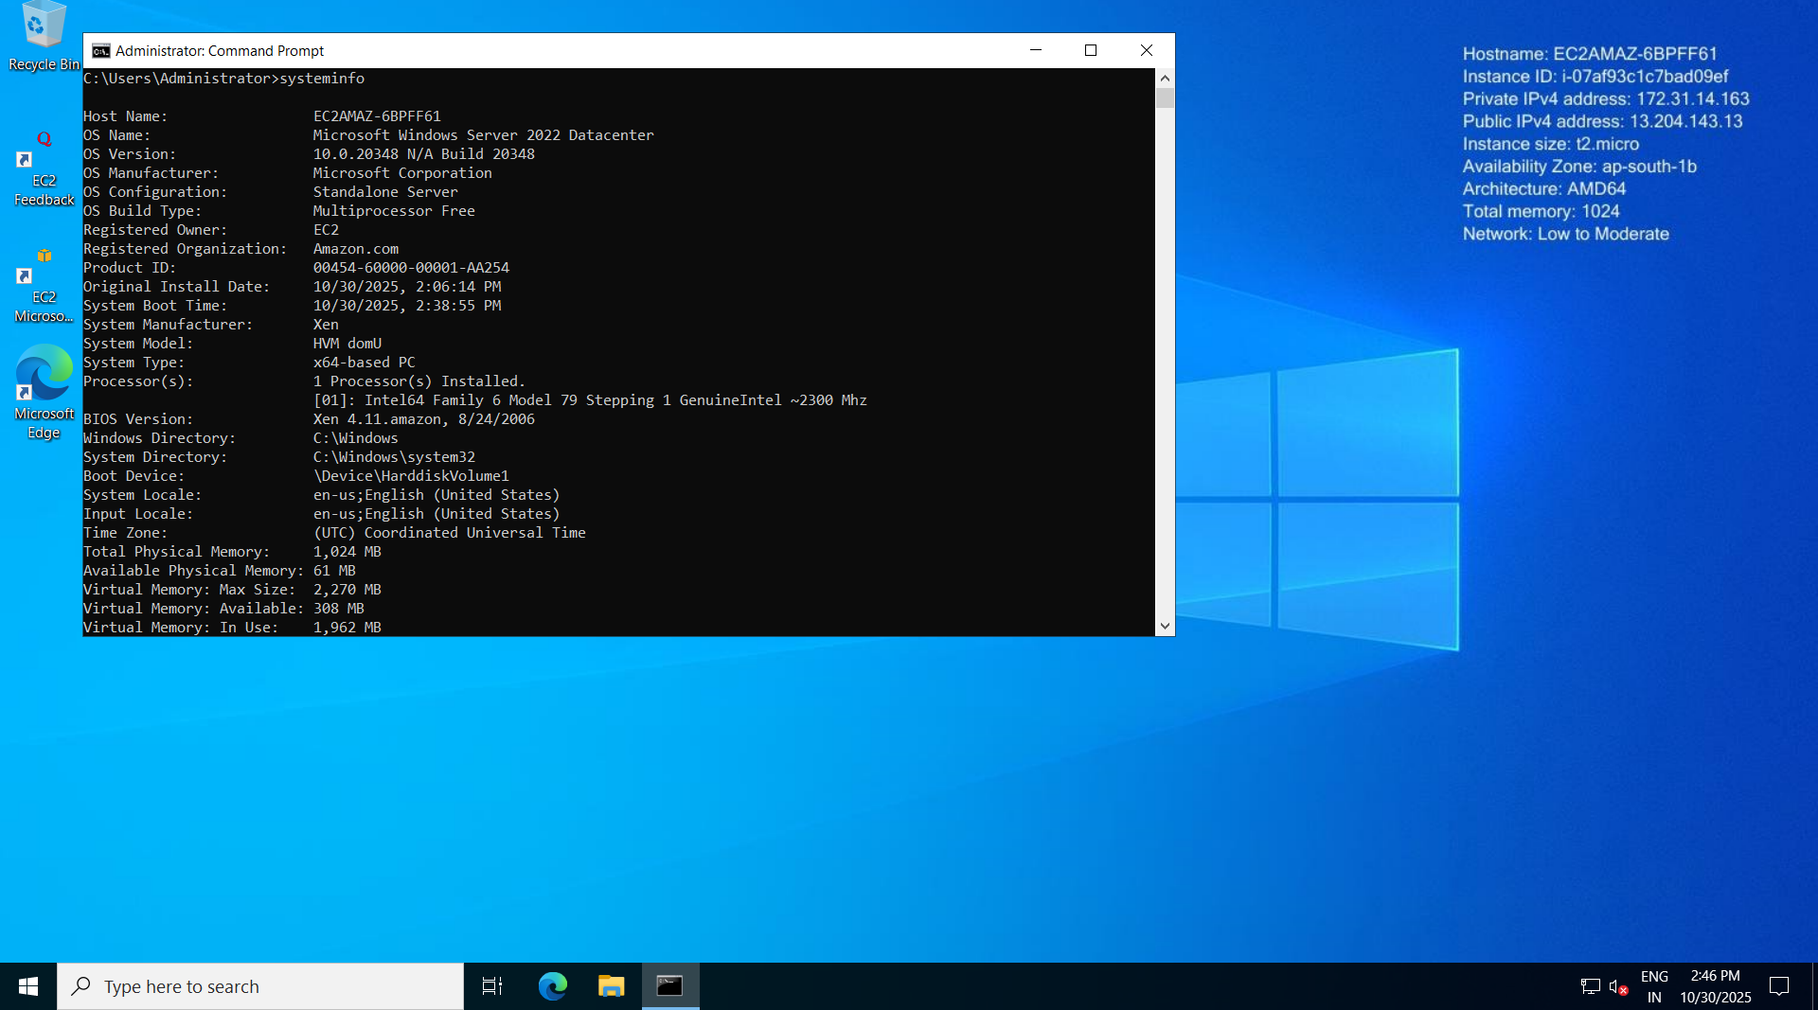

Techstacks needs to be used :

- AWS EC2 (windows)
- RDP (Preavailable in Windows)

How do I submit my work?

- Push all your work files to GitHub (O/P screenshot images must).
- Submit your URLs in the portal.

